Hack3d 2023 Final Challenge Problem Statement

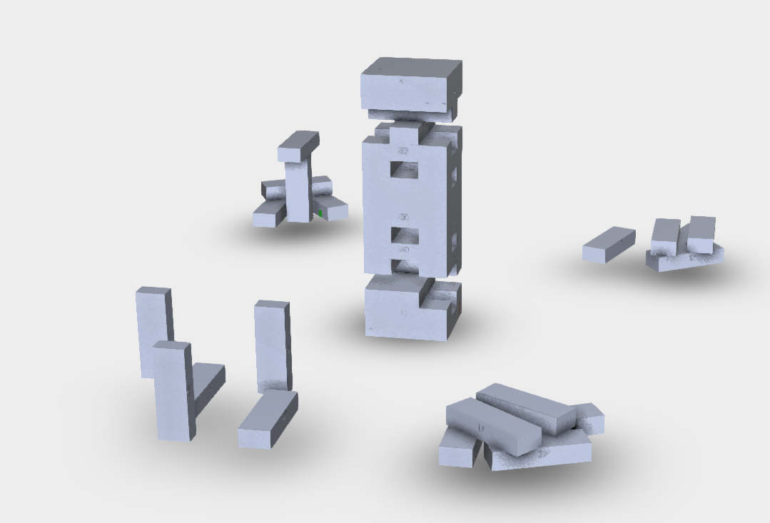

NYU Subsidiary Nyasbro (Red Team) is releasing a new board game. In our previous releases we’ve left clues to our new release in our previous release 𝜈-Jenga.   
  
Your goal (as the blue team) is to examine the 𝜈-Jenga files and determine what the new game we will be releasing is.

Submissions:

1. Each team will submit a zip file (HACK3D_*Team Name*.zip) via EMAIL by 5pm EST containing:
   1. A detailed word document which includes:
      1. A description of the brainstorming process in the team’s approach and explanation of all procedures used in finding clues.
      2. A summary of any other approach attempted that may not have been successful to provide insight into your effort level and thought process.
   2. Any supplementary file to support your report (CAD/STL files, programming scripts, images)
2. Each team will be required to submit a powerpoint presentation via EMAIL by 8am EST Nov. 10 detailing their process in solving the puzzles.
3. Each team will be required to present their findings to our judge panel on November 10th from 9AM - 10AM. (10 minute presentation including Q&A )